C-Kayak Mauritius - with Willows Adventure Sports (WAS)
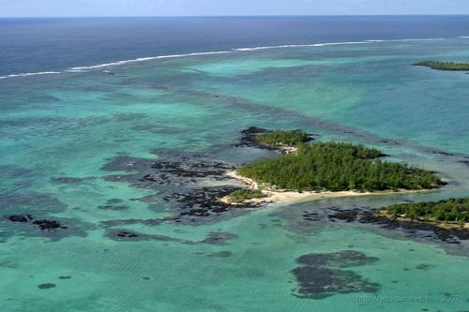Day 1 – The morning is spent packing clothes, kit and food into dry bags then into the hatches, tie kit onto the decks and begin paddling. Our route takes us in a clock wise direction heading south down the East Coast. It is a short 2.5hr paddle to our first camp site on an island called île aux Bernache. This beautiful remote island is about 2 hectares in size providing the paddler with a sense of peace and isolation. As you watch the sun set you get the feeling that you are really on holiday and beginning to relax.
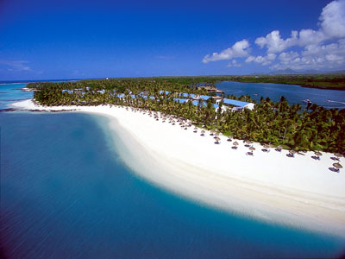
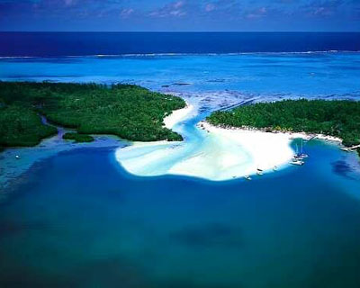Day 2 An early start to avoid any day time winds as we spend most of the day paddling beyond the reef. Paddling south, it will take approximately 3.5 hours to our lunch spot on the beach in front of the St Geran Hotel. After an extended rest time we continue for about one hour and camp at a picnic site on Belle Mare beach.

Day 3 Most of the day is spent paddling in the reef between rocky sections which we have to do at low tide to avoid portaging . The snorkeling is particular impressive. A typical Mauritian lunch on lle de L’Est sampling some refreshments from the beach restaurant. We finish the days paddle at a picnic spot at Grande Rivière Sud Est.
LUNCH SPOT

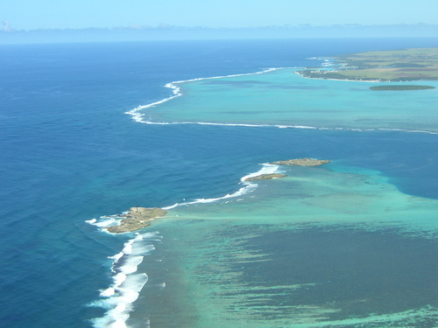
Day 4 We begin paddling up the river to explore the scenic waterfall on the Grande River. We then paddle back down and out into the lagoon ( in the reef) heading south - a brief stop at a Fish Farm situated about 1km off shore, after which we continue south towards lle aux Fouquete island which is our camp site for the night. It forms part of the reef situated about 3kms from the main land. Experience the wild ocean from high cliffs on the “sea side” and calm waters on the “lagoon side”. Stroll through the ruins of a disused light house once used in Napoleonic days.
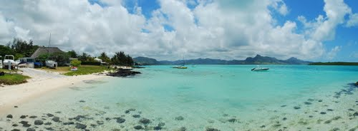Day 5 – A short 2 hour paddle brings us to Blue Bay which provides idyllic snorkeling in the Blue Bay Marine Reserve. We experience excellent hospitality from the Pointe d’Esny Yacht Club and spend time in the fishing village of Mahebourg.

Day 6 - Weather permitting we will continue our paddle along the South Coast to Souillac. This stretch resembles the Wild Coast of the Eastern Cape, isolated and wild with the prevailing south east wind sets the scene for some excellent downwind paddling for the more experienced. There is transport for those who would rather opt for travelling by land.

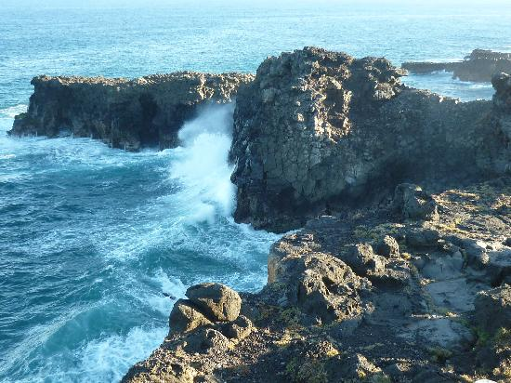Day 7 From Souillac we continue west with a lunch stop at Baie Du Cap - then continue around the South West corner of the Mauritius main land considered the best kite surfing spot in the world. We stop on the island of île aux Benetiers. Another day ends in paddlers paradise as we witness another perfect Mauritian sunset.

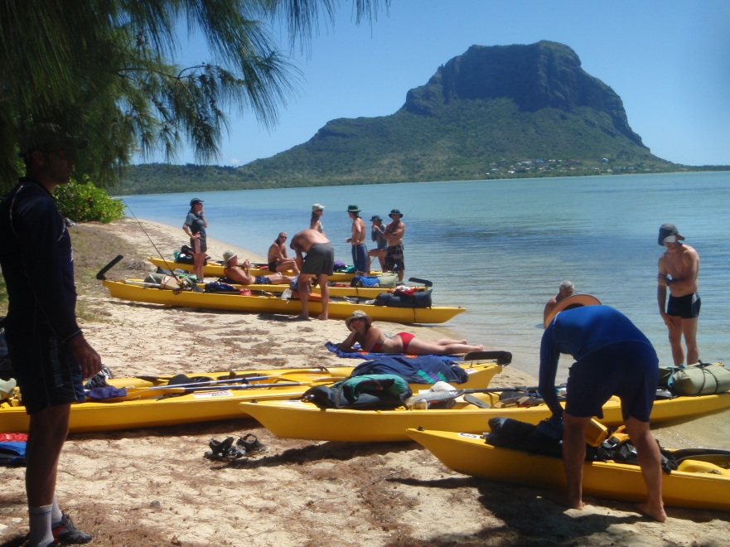

Day 8 - We now heading north up the west coast via Tamarin Bay well known for the sighting of dolphins. The west coast has less wind and the paddling is easier. After a lunch stop at Flic n’ Flac we paddle for another hour to Albion, a quaint bay ideal for relaxing and snorkeling.

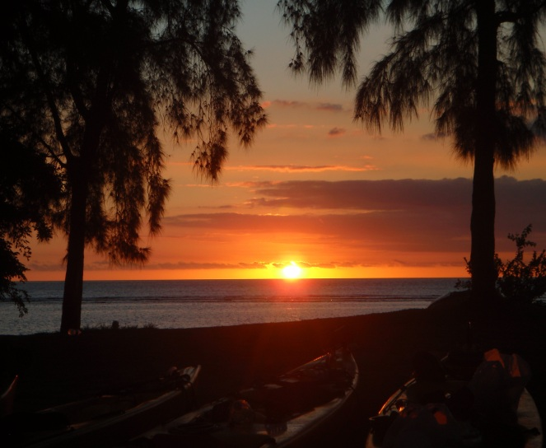Day 9 - Paddling north beyond the reef across the Port Louise Harbour entrance. At this stage we will be at least 2kms off shore to avoid shipping traffic. The end of the day brings us to the beautiful bay of Trombeaue. A short bus ride into Port Louise brings you to the water front promenade and tourist markets.
Day 10 The next morning we paddle past the more touristy areas of the island heading towards Mont Choisy picnic area. Most of the day can be spent doing the “ touristy “things eg: paragliding, diving , hire of motor bikes, sailing, and much more. A short bus/taxi ride brings you to Grand Baie, the tourist capital of the island. There are lots of restaurants and shops and plenty of bargains to be had in the busy markets.
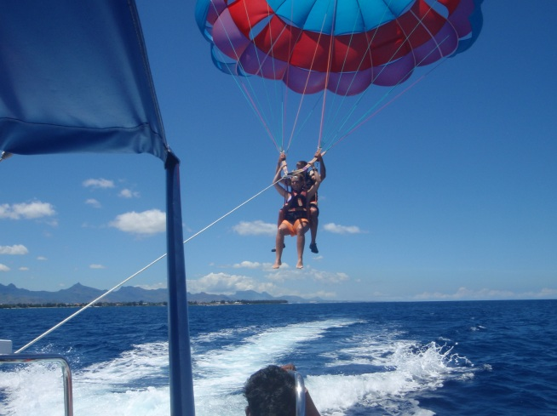
Day 11 The last day sees the paddlers round the northern point of the island finishing at Grand Gaube which completes the 180km circumnavigation.
MAKE YOUR NEXT VISIT TO MAURITIUS AN ADVENTUROUS ONE WITH WILLOWS ADVENTURE SPORTS.

